BIO 102 ASSIGNMENT
NAME: Priscilla Iziegbe Aire
MATRIC NUMBER: 19/MHS01/063
DEPARTMENT: Pre-Medicine and Surgery
COLLEGE: Medicine and Health Sciences
LEVEL: 100

Assignment

- HOW ARE FUNGI IMPORTANT TO MANKIND?

Answers
- They are responsible for the mediation of decay of organic matter.
- Many fungi species mediate the spoilage of foods, wood, clothes and paper.
- They are important in the food industry.
- Mushrooms are eaten by many in the human society.
- Many are plants pathogens causing blights and smuts in cereals.
- Some fungi are parasites of some obnoxious pest and therefore constitute important biological control agents in regard to such pests.

- ILLUSTARTE THE CELL STRUCTURE OF A UNICELLULAR FUNGUS WITH A WELL LABELED DIAGRAM.

Answers
Brewer’s yeast is one of the best known e.g. of unicellular forms in fungi (Bread yeast, Saccharomyces cerevisae, Bakers’ yeast, – causes bread to rise by releasing C02 which gets trapped in the dough). The cell structure is very simple, though the organism is one of the more advanced fungal forms from the point of view of its spore-producing structures.
Yeast cells are found on exposed sugary fluids e.g. Palm wine and sugary fruits where fermentation processes are mediated.
Cells exist in haploid and diploids states. Under favourable environmental conditions, in both states, they multiply rapidly by simple mitotic cell divisions–budding involving nuclear division and division of the cytoplasm in such a way that one segment of the constricted is smaller than the others.
Diploid cell arise from haploid cells by processes of plasmogamy and karyogamy (some kind of fertilization).
A diploid cell may undergo meiosis under certain conditions to produce 4 haploid spores–ascopores (contained in simple structure –an ascus).

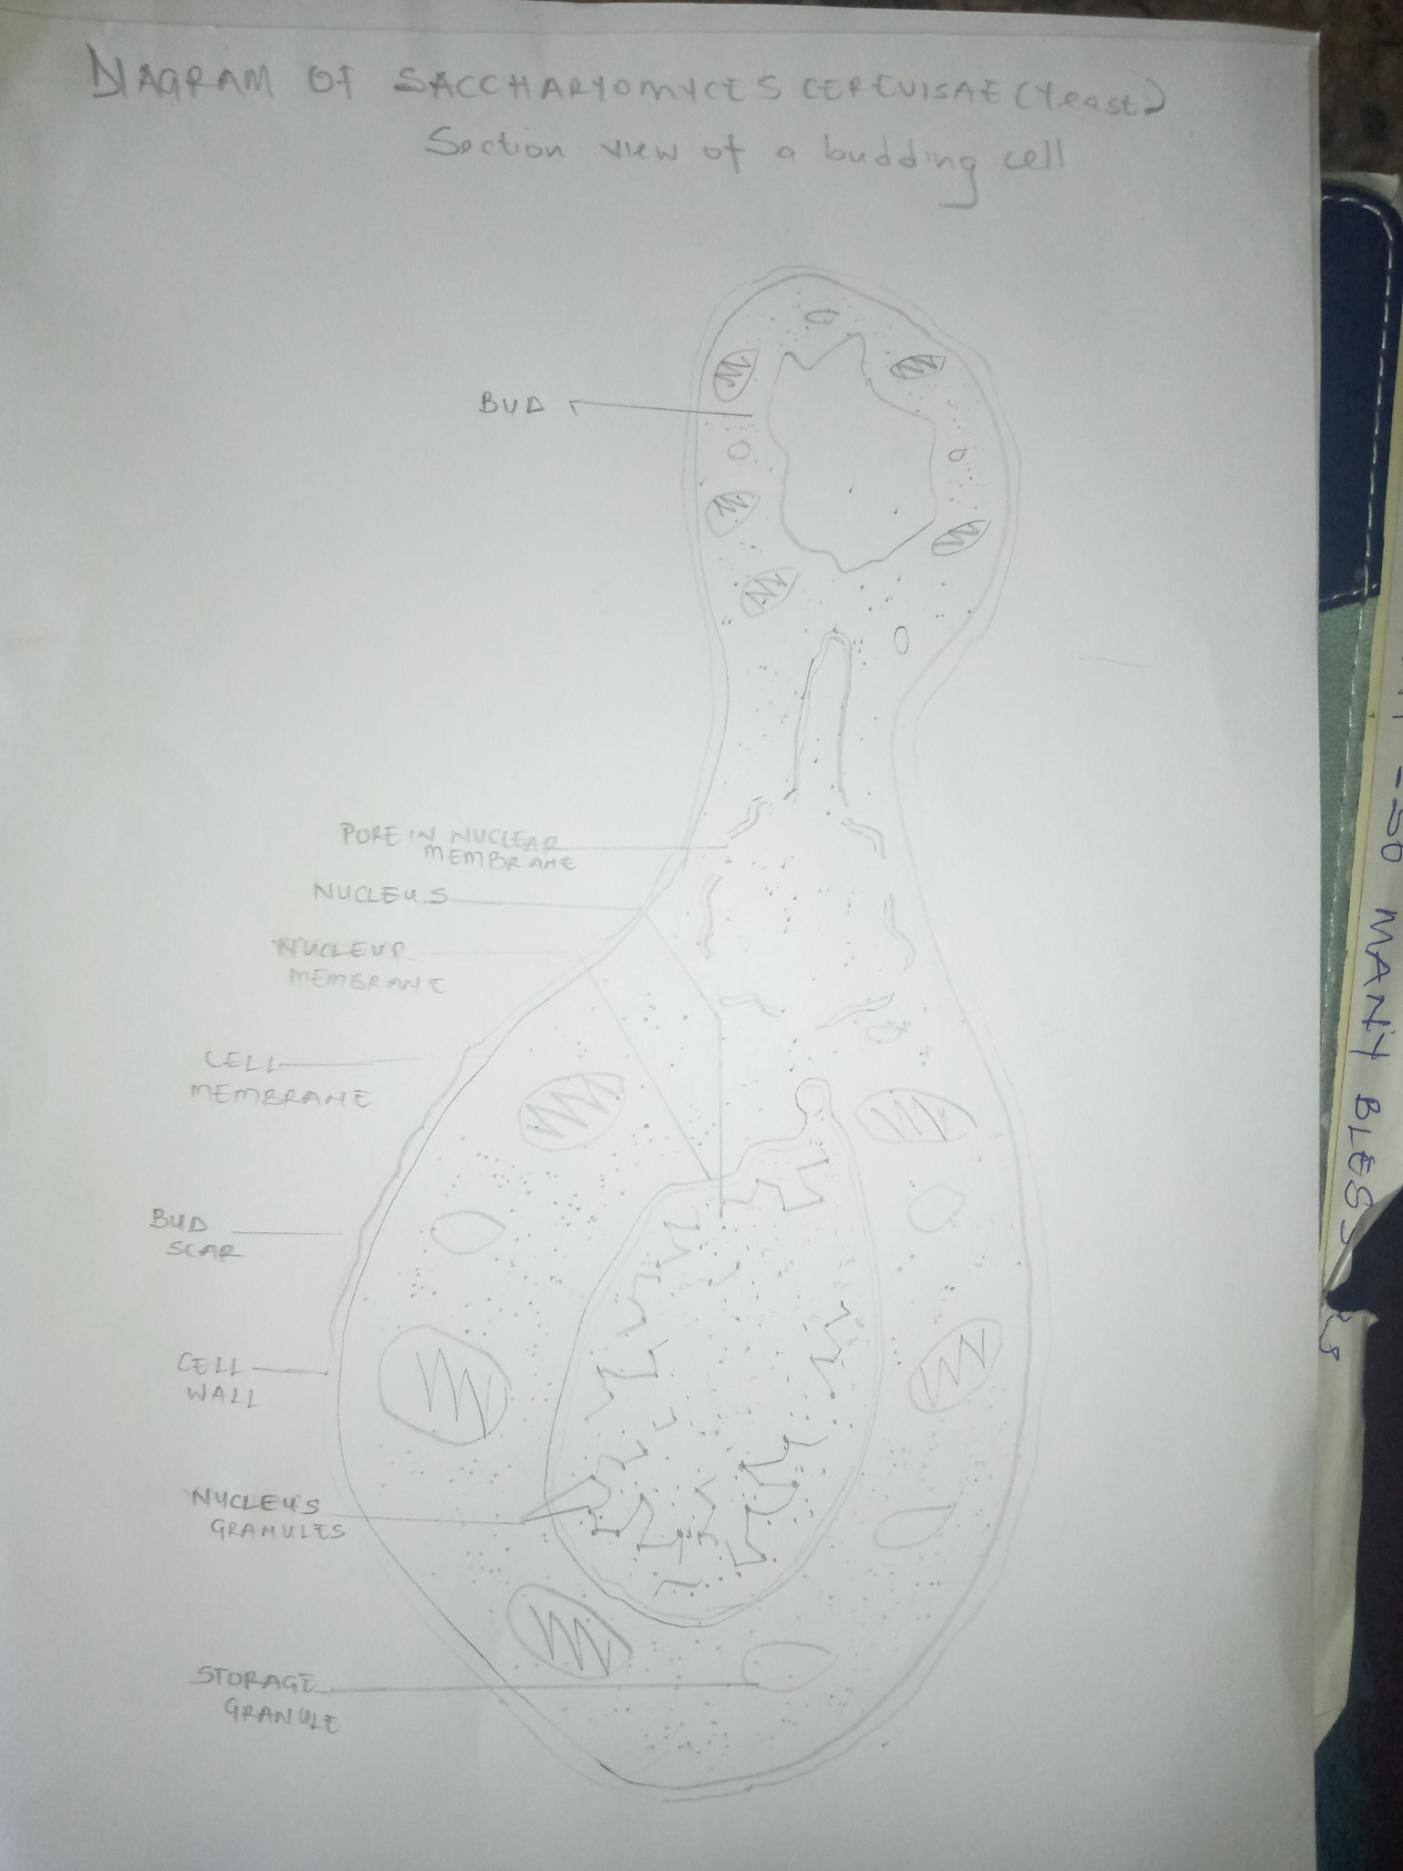

- OUTLINE THE SEXUAL REPRODUCTION IN A TYPICAL FILAMENTOUS FORM OF FUNGI.

Answer
A typical filamentous form of a fungus is Rhizopus stolonifer.

Sexual reproduction occurs when two mating types of hyphae grow in the same medium. Chemical interaction in the two mating types of hyphae induces growth perpendicular to the hyphae in opposite directions. These growths are delimited by a wall such that many nuclei are isolated in what is called a gametangium.
The two gametangia fuse (plasmogamy) and a zygote is formed which may undergo prolonged dormancy meiosis independently.
The zygote germinates under favourable conditions to produce a fruiting which at maturity liberates the haploid spores.

- HOW DO BRYOPHYTES ADAPT TO THEIR ENVIRONMENT.

Answers
- They have definite structures for water and nutrients absorption from the soil; therefore the plant body is divided into two (an aerial portion and a subterranean portion). The subterranean portion is the rhizoid and is not a true root as the case of land plants that are advanced.
- The aerial portion being exposed to the atmosphere demands some modifications that prevents excessive loss of water through the body surface (i.e. desiccation) and
- Some other modifications that permit elimination of excess water from the plant body and not only exchange of gases between the internal parts of the plant and the atmosphere therefore openings are available on the aerial parts of the plants.

- DESCRIBE WITH ILLUSTRATION THE FOLLOWING TERMINOLOGIES;

Answers
- Eusteles; a stele typical of dicotyledonous plants that consists of vascular bundles of xylem and phloem strands with parenchymal cell between the bundles.

- Atactostele; a type of eustele, found in monocots, in which the vascular tissue in the stem exists as scattered bundles.

- Siphonostele; a stele consisting of a core of pith surrounded by concentric layers of xylem and phloem.

- Dictyostele; a stele in which the vascular cylinder is broken up into a longitudinal series or network of vascular strands around a central pith (as in many ferns).

- Illustrate the life cycle of a primitive vascular plant.

Vascular plant in discussion- Psilotum
Psilotum is a very primitive vascular plant; the species represent some of the most primitive vascular plants. The plant body has vertical and horizontal axes not differentiated into stems and roots. Like in the Bryophytes, the plant uses rhizoids to absorb water and mineral salts from the soil.
Three-lobed sporangia (each subtended by two scales) are borne on the vertical axes. The sporangium contains haploid spores and originate from the diploid cells of the stem. Sporangium develops into a globose structure inside which sporogenous cells undergo meiosis to produce haploid spores. Short stalk of the sporangium has a trace connected to the stele of the vertical axis. The plant is homosporous i.e. spores have uniform size and shape.
Spores after liberation germinate into cylindrical, dichotomously-branched gametophytes. Gametophytes are saprophytic and often associated with certain filamentous fungi in mycorrhizal relationship and are hardly visible to the naked eye. Externally, they have many rhizoids but internally, they are largely parenchymatous. At maturity, the terminal ends of cylindrical braches bear the archegonia while the antheridia are borne as protuberances lower down on the branches. Sperms having many flagella are released when antheridia are ripe which swim into the archegonia and the resulting zygote subsequently develops into a sporophyte.

